While finding and cleaning data is an important

first step in data analysis, a concept can be lost if you are not able to organize and

represent the findings effectively to your audience. In this video, you will learn how to represent

your findings by focusing on specific elements to create a successful data findings report. After the data has been collected, cleaned,

and organized the work of interpretation begins. You are now able to obtain a complete view

of the data and hopefully, answer the questions that were formed before starting the analysis. Now, you typically begin to compose a findings

report that explains what was learned. Depending on the stakeholders and how they

receive the information, your report could vary in form. This could include a paper style report, a

slideshow presentation, or maybe even both. The findings report is a crucial part of data

analysis, as it conveys what was discovered. When beginning this process, the collected

data and information may seem a little overwhelming. The best way to get through this block is

to begin by creating an outline. By completing an outline, you can then get

a complete picture and begin to write in a precise but simple manner. While there are many different formats for

creating a data-driven presentation, we have created a simple outline that is easy to follow

yet effective. When creating your outline always remember

to structure it towards your audience and create a presentation that is appropriate

for your situation. You first begin with your cover page. This beginning section will have the title

of your presentation, your name, and then the date. The next section in your outline will be an

executive summary and then the table of contents. The table of contents will contain the sections

and subsections of your report in order to give your audience an overview of the contents. This also enables readers to go directly to

a specific section that may be more important to them. Continue your presentation with the introduction,

methodology, results, discussion, conclusion, and finally the appendix. Please note the depth and length for each

element may vary depending on the audience and format of report. The first step in creating your report is

properly creating an executive summary. This summary will briefly explain the details

of the project and should be considered a stand-alone document. This information is taken from the main points

of your report and while it is acceptable to repeat information, no new information

is presented. The next section, after the table of contents,

is the introduction. The introduction explains the nature of the

analysis, states the problem, and gives the questions that were to be answered by performing

the analysis. The next section is methodology. Methodology explains the data sources that

were used in the analysis and outlines the plan for the collected data. For example, was the cluster or regression

method used to analyze the data? Next, we have the results section. This section goes into the detail of the data

collection, how it was organized, and how it was analyzed. This portion would also contain the charts

and graphs that would substantiate the results and call attention to the more complex or

crucial findings. By providing this interpretation of data,

you are able to give a detailed explanation to the audience and convey how it relates to the

problem that was stated in the introduction. Next is the discussion of the report findings

and implications. For this section you would begin to engage

the audience with a discussion of your implications that were drawn from the research. For example, let’s say you were conducting

research for top programming languages for college graduates. Would you find they need to learn multiple

languages to remain competitive in the job market, or would one language always reign

supreme? We have now reached the conclusion of the

report findings. This final section should reiterate the problem

given in the introduction and gives an overall summary of the findings. It would also state the outcome of the analysis

and if any other steps would be taken in the future. Lastly, we have the appendix. This section would contain information that

really didn’t fit in the main body of the report, but you deemed it was still important

enough to include. This type of information could include locations

where the raw data was collected or other details such as resources, acknowledgements

or references. In this video, we learned about the important

elements in creating a successful data findings report. In the next video, we will learn the best

practices when presenting your findings.

**Course Text Book: ‘Getting Started with Data Science’ Publisher: IBM Press; 1 edition (Dec 13 2015) Print.**

**Author: Murtaza Haider**

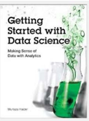

Prescribed Reading: Chapter 3 Pg. 60-62

### The Report Structure

Before starting the analysis, think about the structure of the report. Will it be a brief report of five or fewer pages, or will it be a longer document running more than 100 pages in length? The structure of the report depends on the length of the document. A brief report is more to the point and presents a summary of key findings. A detailed report incrementally builds the argument and contains details about other relevant works, research methodology, data sources, and intermediate findings along with the main results.

I have reviewed reports by leading consultants including Deloitte and McKinsey. I found that the length of the reports varied depending largely on the purpose of the report. Brief reports were drafted as commentaries on current trends and developments that attracted public or media attention. Detailed and comprehensive reports offered a critical review of the subject matter with extensive data analysis and commentary. Often, detailed reports collected new data or interviewed industry experts to answer the research questions.

Even if you expect the report to be brief, sporting five or fewer pages, I recommend that the deliverable follow a prescribed format including the cover page, table of contents, executive summary, detailed contents, acknowledgments, references, and appendices (if needed).

I often find the cover page to be missing in documents. It is not the inexperience of undergraduate students that is reflected in submissions that usually miss the cover page. In fact, doctoral candidates also require an explicit reminder to include an informative cover page. I hasten to mention that the business world sleuths are hardly any better. Just search the Internet for reports and you will find plenty of reports from reputed firms that are missing the cover page.

At a minimum, the cover page should include the title of the report, names of authors, their affiliations, and contacts, the name of the institutional publisher (if any), and the date of publication. I have seen numerous reports missing the date of publication, making it impossible to cite them without the year and month of publication. Also, from a business point of view, authors should make it easier for the reader to reach out to them. Having contact details at the front makes the task easier.

"A table of contents (ToC)" is like a map needed for a trip never taken before. You need to have a sense of the journey before embarking on it. A map provides a visual proxy for the actual travel with details about the landmarks that you will pass by in your trip. The ToC with main headings and lists of tables and figures offers a glimpse of what lies ahead in the document. Never shy away from including a ToC, especially if your document, excluding cover page, table of contents, and references, is five or more pages in length.

Even for a short document, I recommend an "abstract" or an "executive summary". Nothing is more powerful than explaining the crux of your arguments in three paragraphs or less. Of course, for larger documents running a few hundred pages, the executive summary could be longer. An "introductory section" is always helpful in setting up the problem for the reader who might be new to the topic and who might need to be gently introduced to the subject matter before being immersed in intricate details. A good follow-up to the introductory section is a review of available relevant research on the subject matter. The length of the literature review section depends upon how contested the subject matter is. In instances where the vast majority of researchers have concluded in one direction, the literature review could be brief with citations for only the most influential authors on the subject. On the other hand, if the arguments are more nuanced with caveats aplenty, then you must cite the relevant research to offer adequate context before you embark on your analysis. You might use the literature review to highlight gaps in the existing knowledge, which your analysis will try to fill. This is where you formally introduce your research questions and hypothesis.

In the "methodology" section, you introduce the research methods and data sources you used for the analysis. If you have collected new data, explain the data collection exercise in some detail. You will refer to the literature review to bolster your choice for variables, data, and methods and how they will help you answer your research questions.

The results section is where you present your empirical findings. Starting with descriptive statistics (**see Chapter 4, "Serving Tables"**) and illustrative graphics (**see Chapter S, "Graphic Details" for plots and Chapter 10, "Spatial Data Analytics" for maps**), you will move toward formally testing your hypothesis (**see Chapter 6, "Hypothetically Speaking"**).

In case you need to run statistical models, you might turn to regression models (**see Chapter 7, "Why Tall Parents Don't Have Even Taller Children"**) or categorical analysis (**see Chapters 8, "To Be or Not to Be" and 2., "Categorically Speaking About Categorical Data"**). If you are working with time-series data, you can turn to Chapter 11, **Doing Serious Time with Time Series.** You can also report results from other empirical techniques that fall under the general rubric of data mining (**see Chapter 12, "Data Mining for Gold"**). Note that many reports in the business sector present results in a more palatable fashion by holding back the statistical details and relying on illustrative graphics to summarize the results.

The results section is followed by the discussion section, where you craft your main arguments by building on the results you have presented earlier.

The "discussion section" is where you rely on the power of narrative to enable numbers to communicate your thesis to your readers. You refer the reader to the research question and the knowledge gaps you identified earlier. You highlight how your findings provide the ultimate missing piece to the puzzle.

Of course, not all analytics return a smoking gun. At times, more frequently than I would like to acknowledge, the results provide only a partial answer to the question and that, too, with a long list of caveats.

In the "conclusion" section, you generalize your specific findings and take on a rather marketing approach to promote your findings so that the reader does not remain stuck in the caveats that you have voluntarily outlined earlier. You might also identify future possible developments in research and applications that could result from your research. What remains is housekeeping, including a list of references, the acknowledgment section (**acknowledging the support of those who have enabled your work is always good**), and "appendices", if needed.

## Have You Done Your Job as a Writer?

As a data scientist, you are expected to do thorough analysis with the appropriate data, deploying the appropriate tools. As a writer, you are responsible for communicating your findings to the readers. Transport Policy, a leading research publication in transportation planning, offers a checklist for authors interested in publishing with the journal. The checklist is a series of questions authors are expected to consider before submitting their manuscripts to the journal. I believe the checklist is useful for budding data scientists and, therefore, I have reproduced it verbatim for their benefit.

* Have you told readers, at the outset, what they might gain by reading your paper?
* Have you made the aim of your work clear?
* Have you explained the significance of your contribution?
* Have you set your work in the appropriate context by giving sufficient background (including a complete set of relevant references) to your work?
* Have you addressed the question of practicality and usefulness?
* Have you identified future developments that might result from your work?
* Have you structured your paper in a clear and logical fashion?

Okay, you’ve spent weeks, maybe months, studying

the data and the time has come to report your findings. The questions have been answered, and you

feel good about the story. How will you speak to your audience so they

leave with the intended message? In this video, learn how to present your findings

in a way that will engage and keep the attention of your audience. Delivering data-driven presentations may seem

easy, but there are a few important factors to remember in accurately conveying your message. Make sure charts and graphs are not too small

and are clearly labeled, Use the data only as supporting evidence, Share only one point from each chart or graph,

and Eliminate data that does not support the key

message. Have you ever sat through a presentation and

the information being presented was difficult to read or understand? While this may seem apparent, small charts

and labels can be easily overlooked. Make sure to test the visualizations by sitting

at different distances, similar to your audience, and if the data cannot be seen clearly then

maybe a redesign should be considered. When preparing the report, you may feel the

only way to explain the findings is to pack the slides with data. While this may seem sensible as a data analyst,

your audience will probably not appreciate the intricacies of the data and just see a

pile of numbers. To resolve this issue, begin by forming the

key messages that need to be conveyed to the audience and build the story around these

messages. After forming the outline, go back and insert

the data to support your findings. By not relying heavily on the data and using

this method to create the presentation, you will create a story that is engaging and interesting

to your audience. Presenting your data using charts and graphs

is the best way to get your message across, however, if you are supplying

too much information it can be confusing. For example, looking at this pie chart, can

you decipher what the key message is, and what the presenter is trying to convey? In the example, the chart has so much information

it is hard to determine what point the presenter is trying to make and what the focus should

be for the audience. By sticking with one idea and not summarizing

multiple points into one visualization, you are able to accurately convey the idea to

the audience and avoid any confusion. Data analysts can spend months researching

data, however, some items that seem interesting to the analyst may not be relevant to the

project. Trying to explain every little detail to your

audience and not recognizing irrelevant data could damage the key message. By eliminating this unnecessary data and highlighting

only data points that support your key ideas, you will keep the presentation clear and concise. In this video, we learned about creating a

data-driven presentation that will keep the audience engaged and how to deliver a clear

and concise message.

# Hands-on Lab : Getting Started with PowerPoint for the Web

**Estimated time needed:** 20 minutes

Microsoft PowerPoint is the most widely used presentation software even three decades after its initial release. For all these years it has been available as a standard application that needed to be installed on your desktop; but it is not just a desktop app anymore. Now, you can even use PowerPoint when you're online by using 'PowerPoint for the web' - and run it right in your web browser without installing anything on your desktop!

'PowerPoint for the Web' (sometimes referred to as PowerPoint Online) can be used at no charge as part of a free Microsoft account. Although it does not have all of the capabilities of the desktop and paid online versions, the free web version provides many of the key features.

# Software Used in this Lab

For the story telling/project report of this module, you will be using the free 'PowerPoint for the web' version as this is available to everyone.

Although you can use the PowerPoint Desktop software if you have access to this version, it is recommended that you use PowerPoint for the web for your project report as it is available for free, and there are some small differences in the interface and available features.

# Objectives

After completing this lab, you will be able to:

* Sign up for a Microsoft Account to use PowerPoint for the web
* Sign in and open a new blank presentation in PowerPoint for the web

# Exercise 1: Sign-up for a Microsoft Account to use PowerPoint for the Web

In this exercise, you will sign up for a Microsoft Account to use PowerPoint for the web.

If you already have a Microsoft account, you can skip Exercise 1 and proceed to Exercise 2 directly.

1. Go to [www.office.com](https://www.office.com/?utm_medium=Exinfluencer&utm_source=Exinfluencer&utm_content=000026UJ&utm_term=10006555&utm_id=NA-SkillsNetwork-Channel-SkillsNetworkCoursesIBMDA0321ENSkillsNetwork21426264-2022-01-01). Click **Sign in**
2. 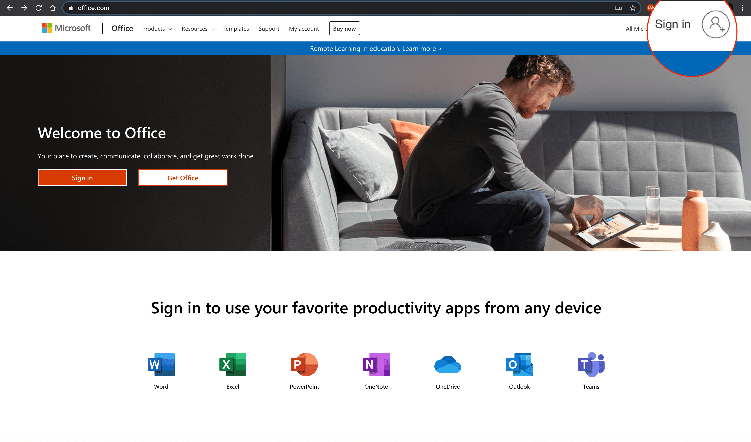
3. Click **Create one!**
4. 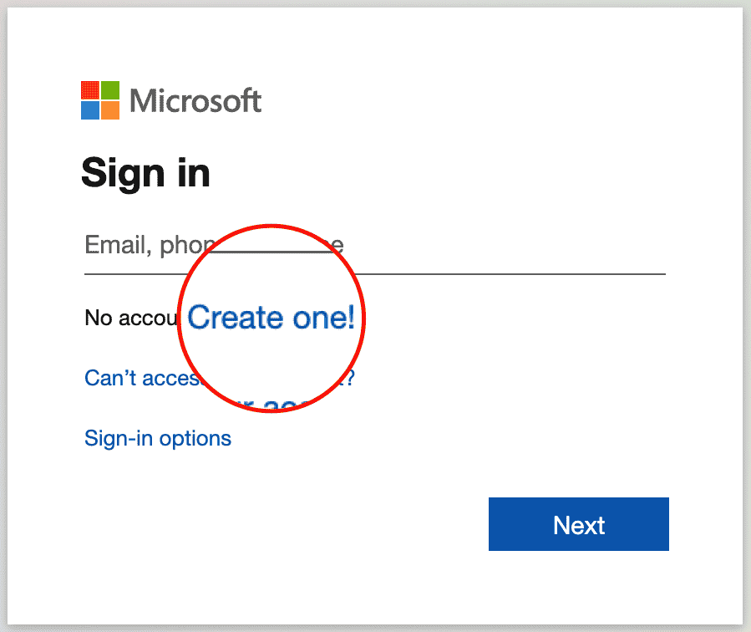
5. Enter your existing email id with which you want to create a Microsoft account. Click **Next**.
6. 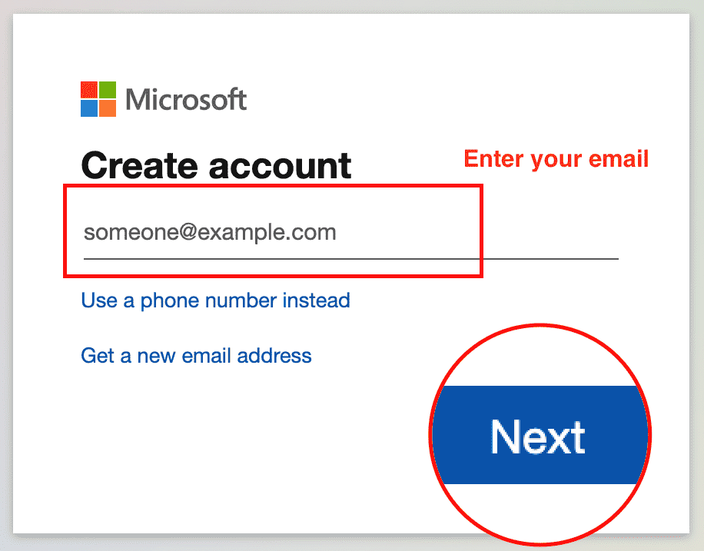
7. Enter your password and click **Next**.
8. 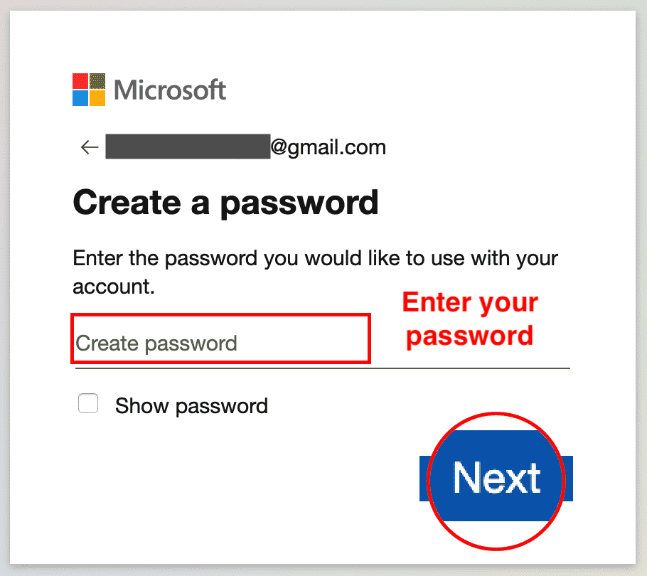
9. Enter the code you received by email. Click **Next**.
10. 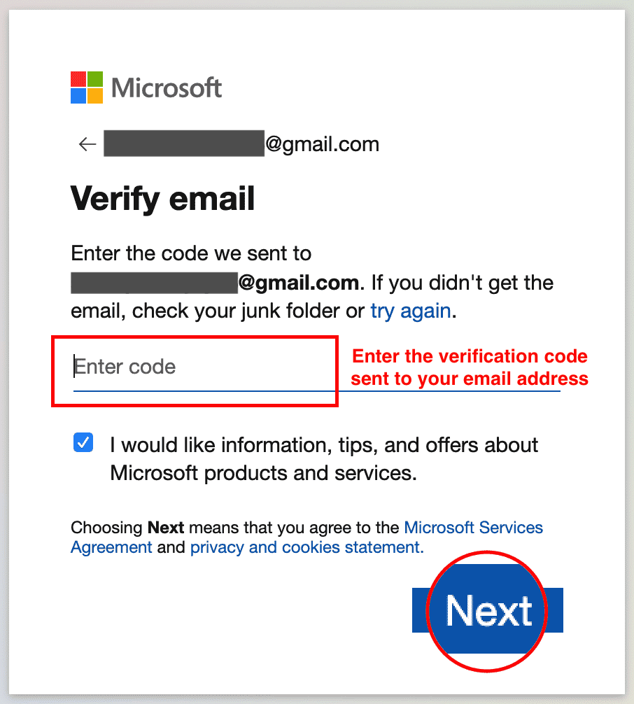
11. Enter your phone number and click **Send Code**.
12. 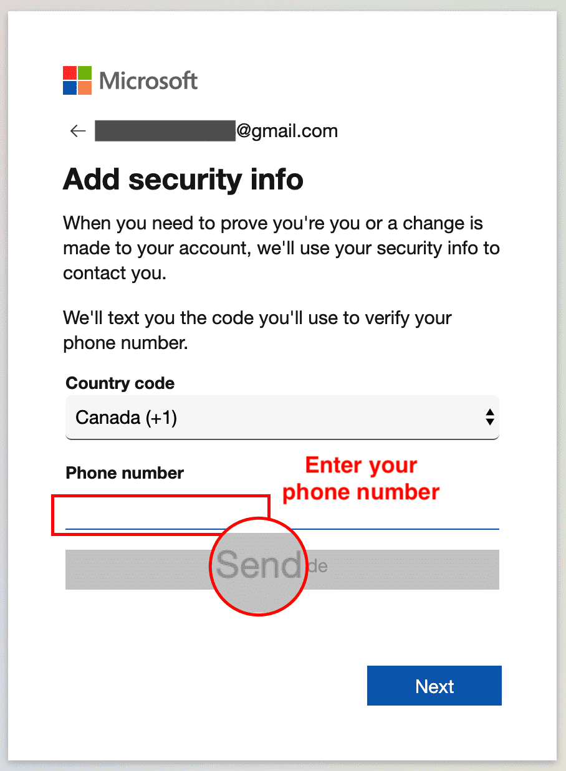
13. Enter the access code you received as a text on your phone, then click **Next**.
14. 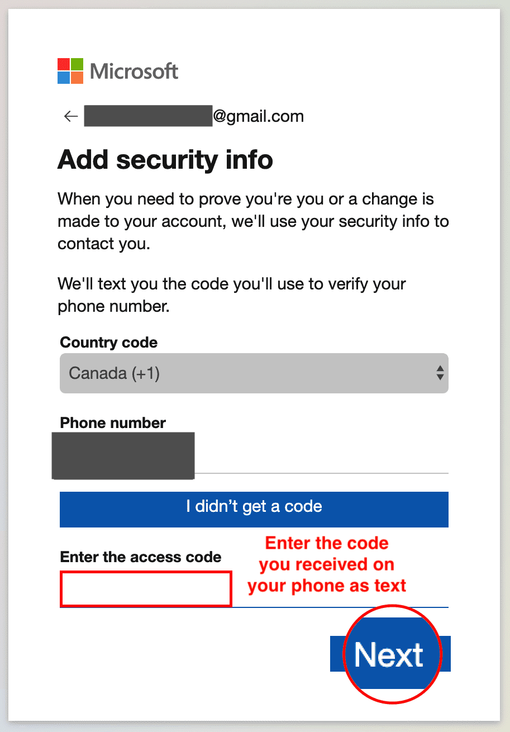
15. You are now done with the sign up procedure. Now since you are signed in after sign up at this stage, you can proceed directly to **Task B** of **Exercise 2**.
16. 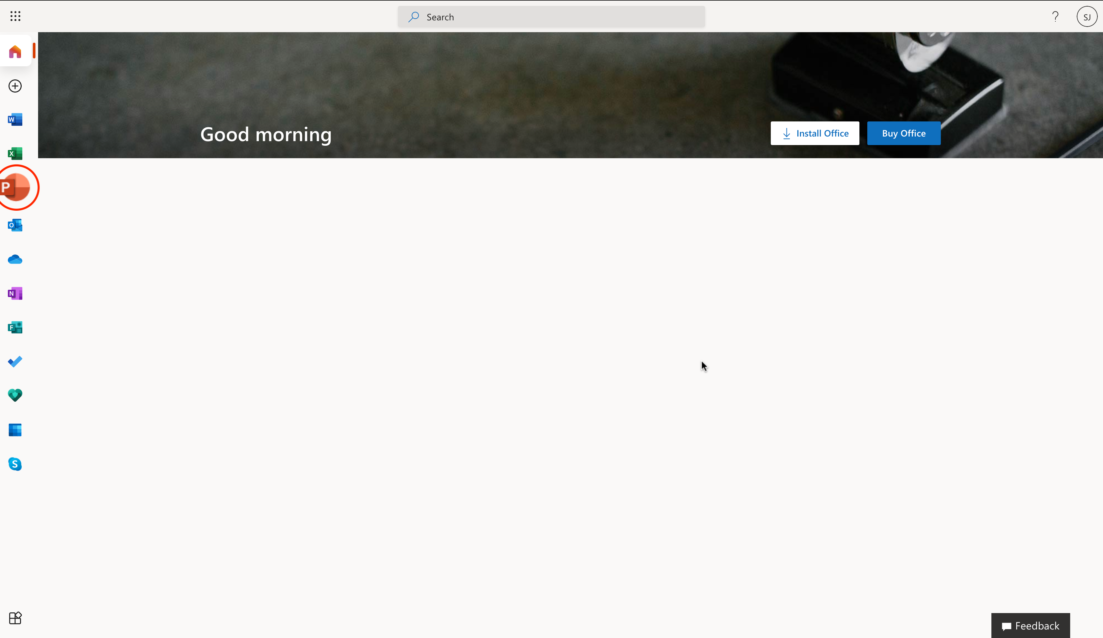

# Exercise 2: Sign-in, Upload and Open presentation in PowerPoint for the Web

In this exercise, you will sign in to PowerPoint for the web. Then open a new blank presentation. Lastly upload, open and edit a presentation.

## Task A: Sign in to PowerPoint for the Web

1. Go to [www.office.com](https://www.office.com/?utm_medium=Exinfluencer&utm_source=Exinfluencer&utm_content=000026UJ&utm_term=10006555&utm_id=NA-SkillsNetwork-Channel-SkillsNetworkCoursesIBMDA0321ENSkillsNetwork21426264-2022-01-01). Click **Sign in**.
2. 
3. Enter your sign in email.
4. 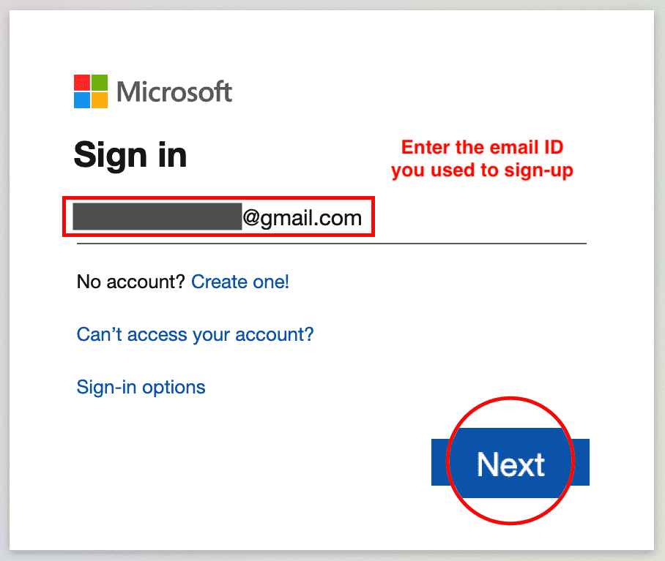
5. Enter your password.
6. 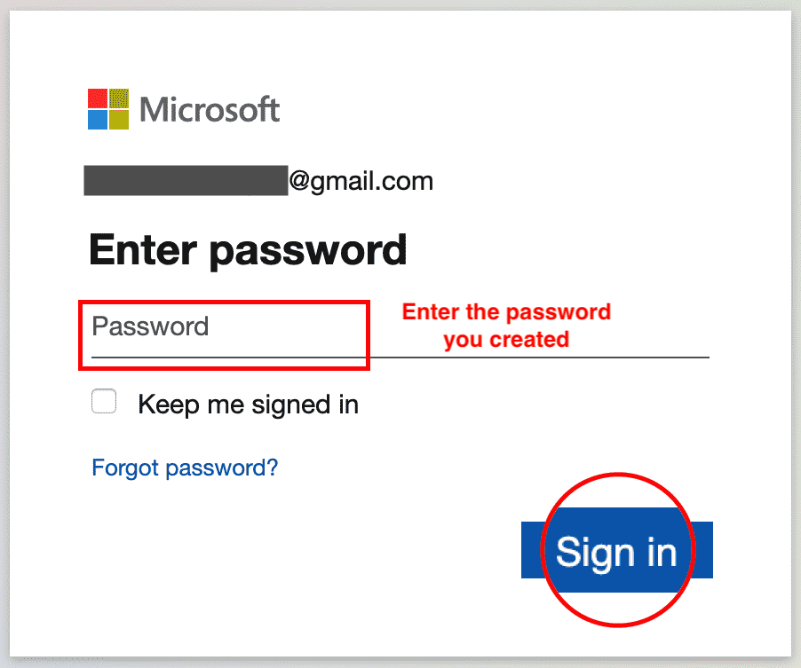
7. You are now signed in.
8. 

## Task B: Open a new blank presentation in PowerPoint for the Web

1. Click on the **PowerPoint** icon.
2. 
3. Click **New blank presentation**.
4. 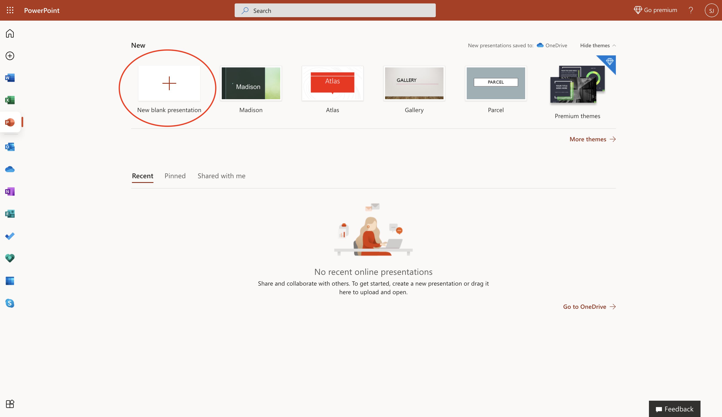
5. You have successfully opened a new blank presentation in PowerPoint for the web.
6. 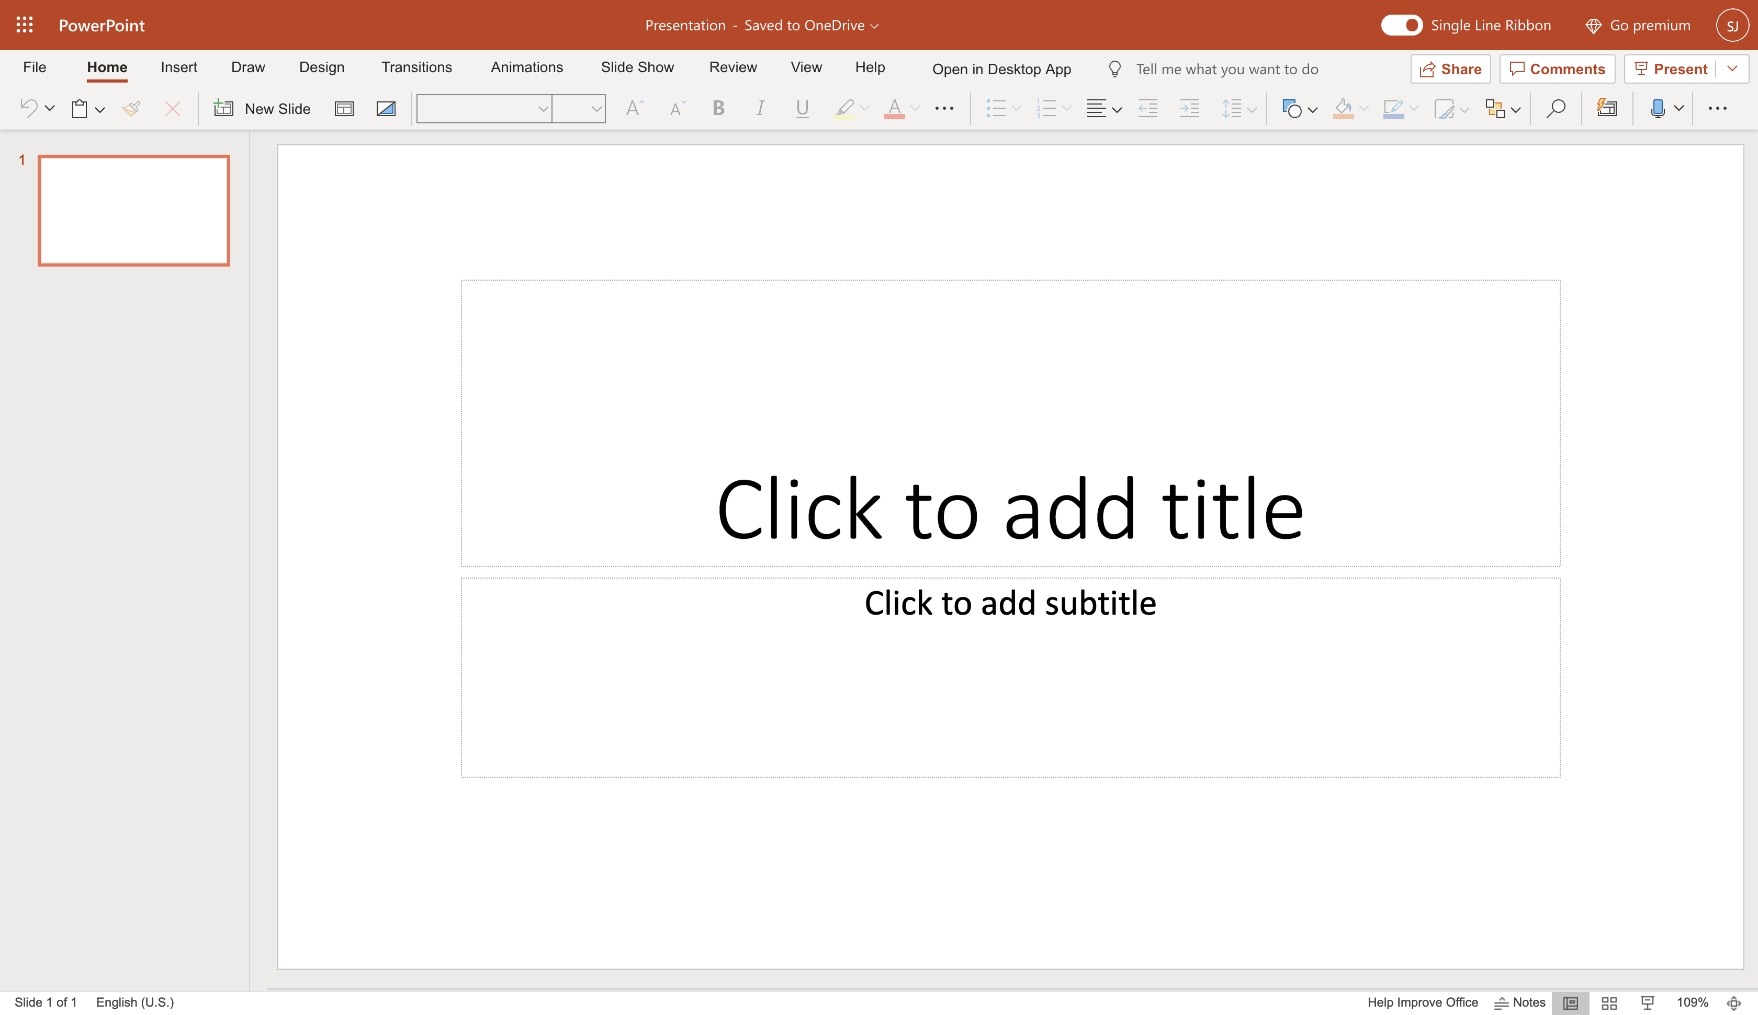

## Task C: Upload, Open and Edit a Presentation

1. Download the file [capstone-story-template.pptx](https://cf-courses-data.s3.us.cloud-object-storage.appdomain.cloud/IBM-DA0321EN-SkillsNetwork/labs/module%206/Lab%20-%20Getting%20Started%20with%20PowerPoint%20for%20the%20Web/capstone-story-template.pptx).
2. To upload and open a presentation file in PowerPoint for the web, click the **App Launcher** (cube of dots) in the top left corner. Click **PowerPoint** icon.
3. 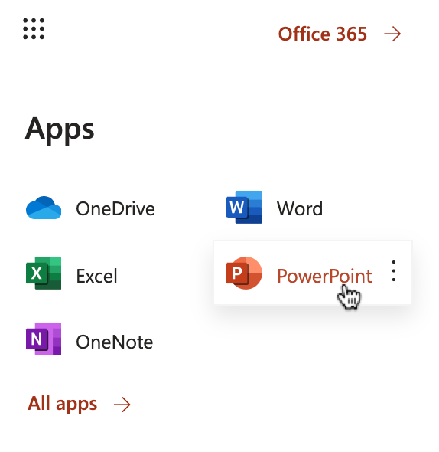
4. Click **Upload and open...** and select the **capstone-story-template.pptx** file.
5. 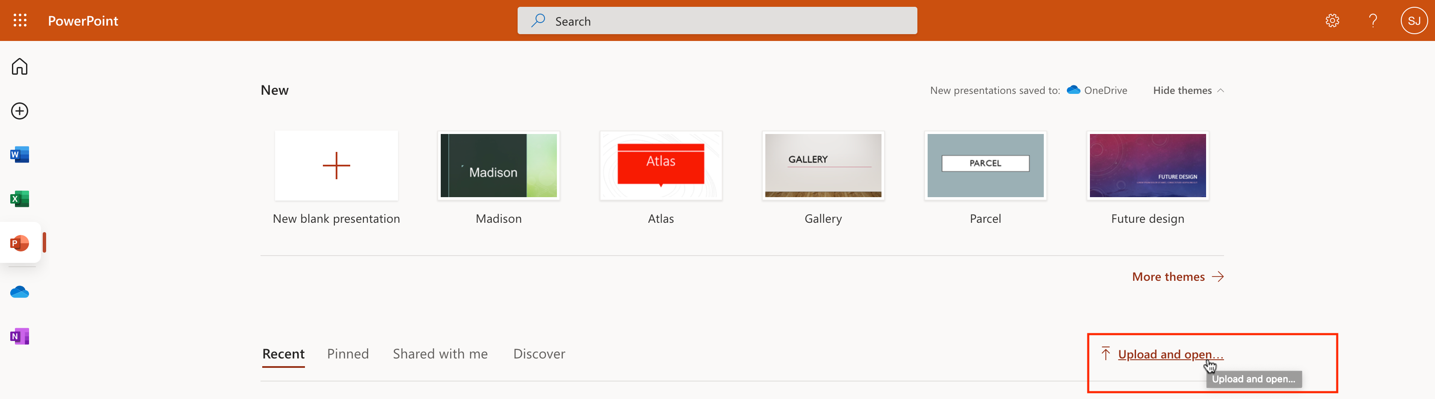
6. The file will be uploaded to your OneDrive of the Microsoft Account you signed up and used to open PowerPoint for the web.
7. 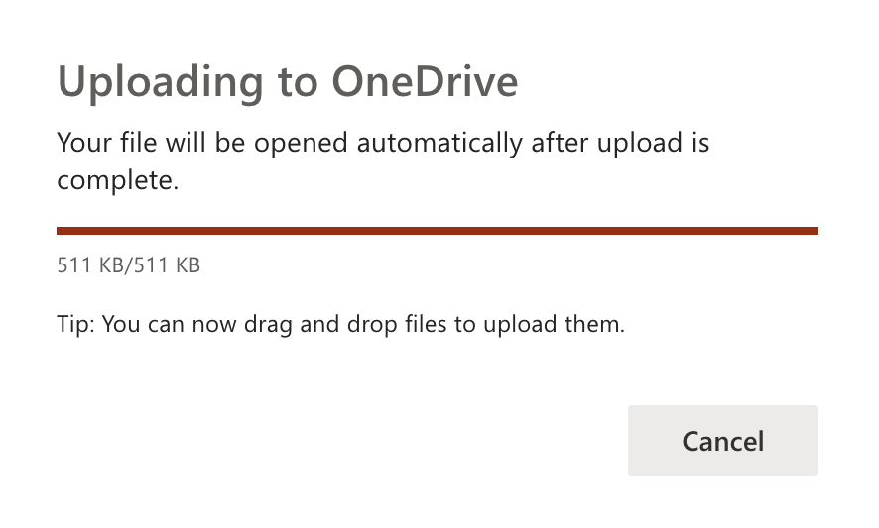
8. Now edit the presentation with your information required for this module. Your edits are saved automatically.
9. 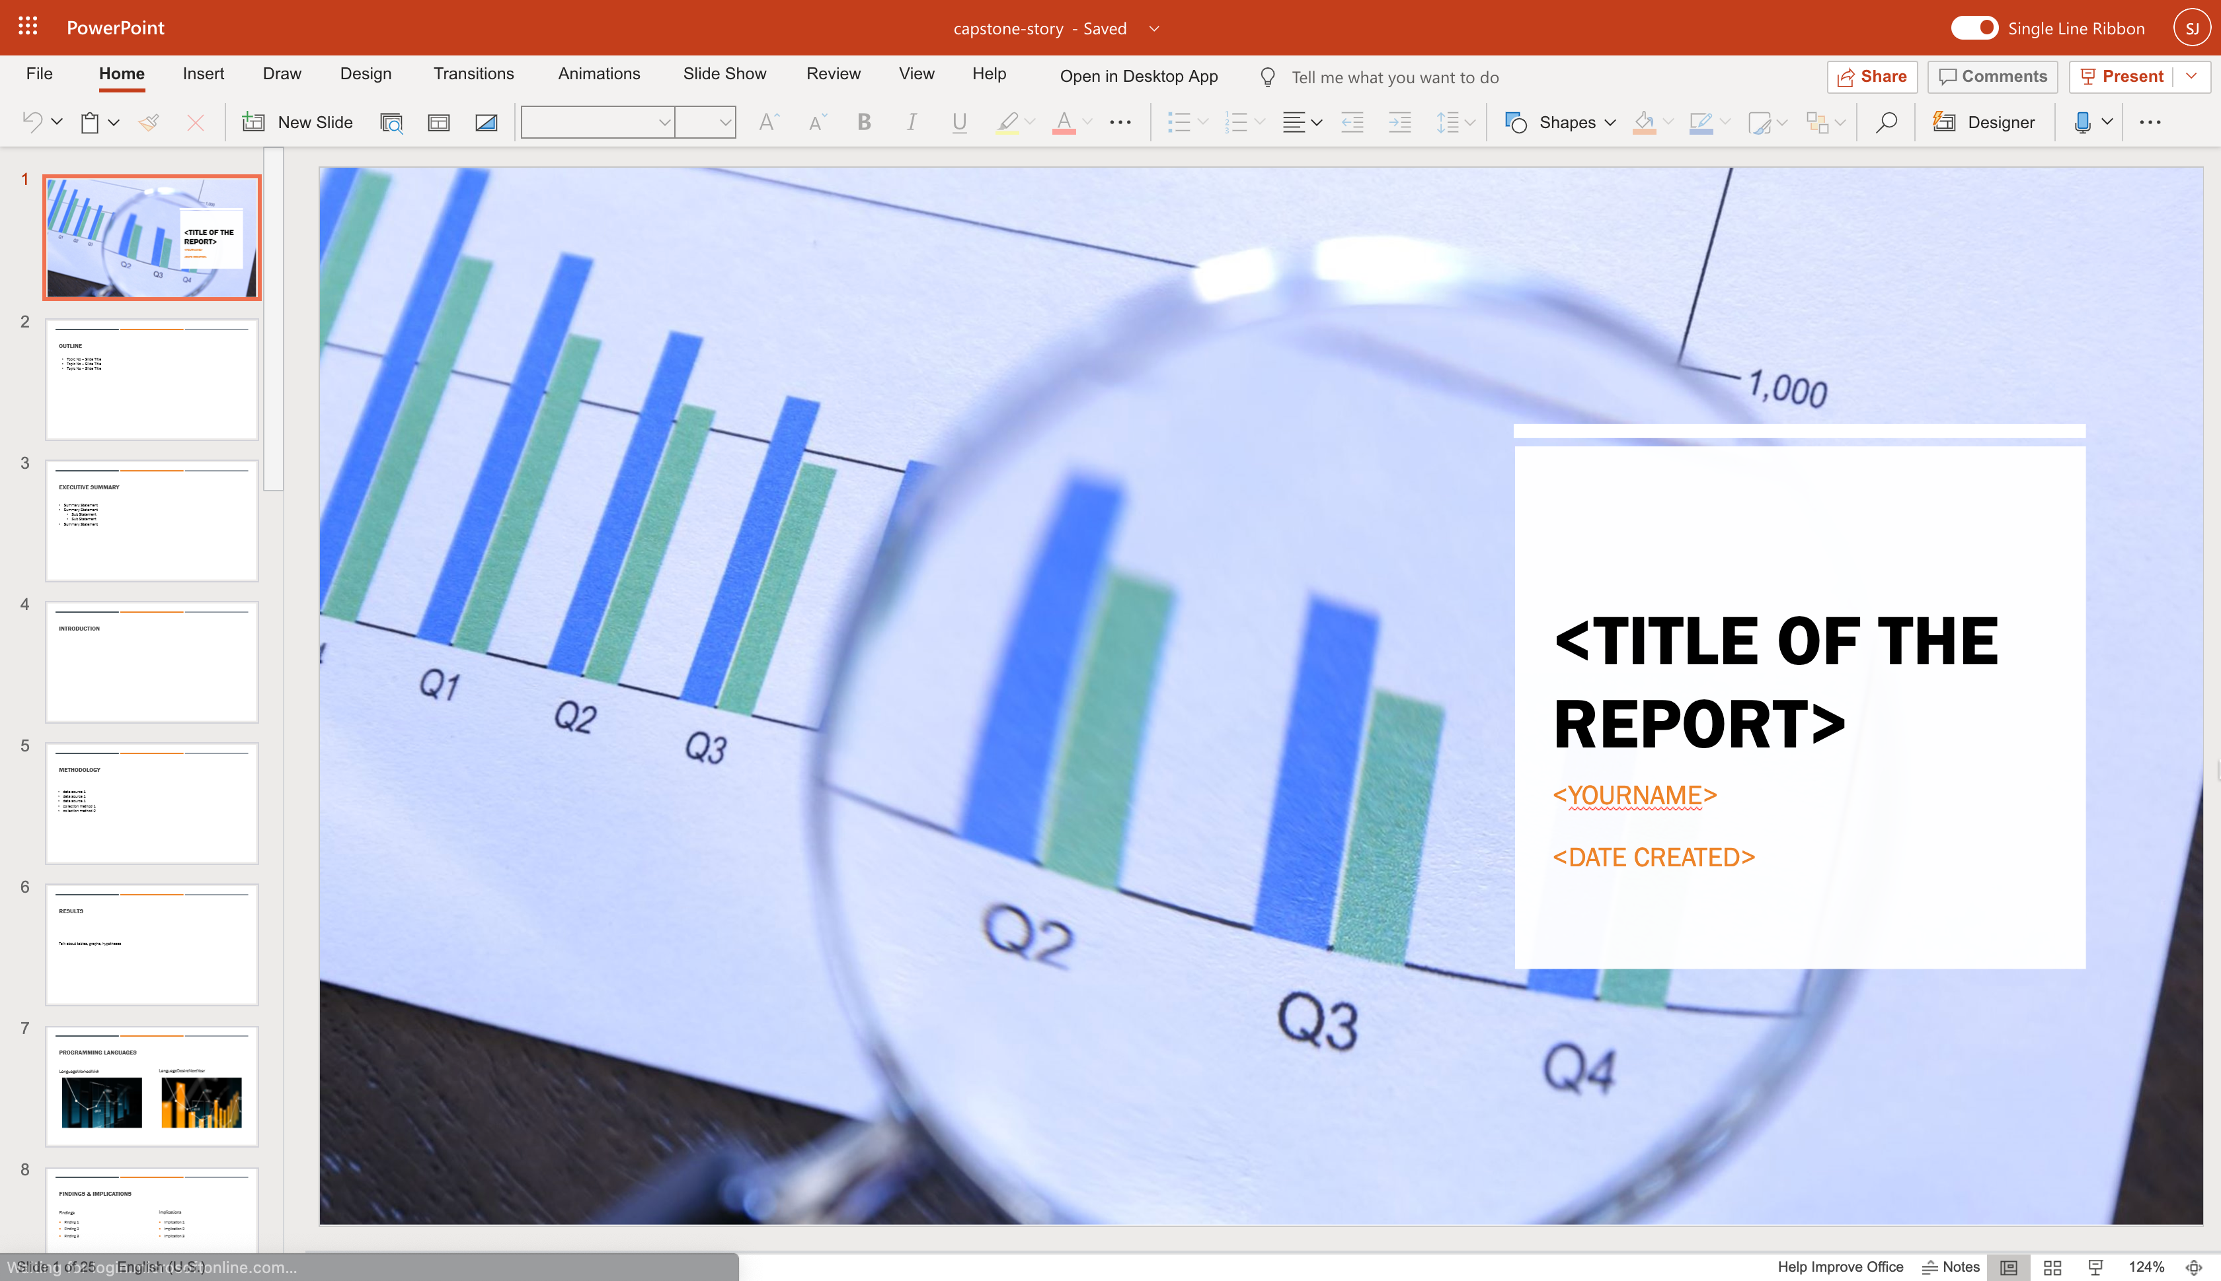

### Congratulations! You have completed this Lab.

# Hands-on Lab : Basics of PowerPoint

**Estimated time needed:** 15 minutes

Microsoft PowerPoint is the most widely used presentation software even three decades after its initial release. For all these years it has been available as a standard application that needed to be installed on your desktop; but it is not just a desktop app anymore. Now, you can even use PowerPoint when you're online by using 'PowerPoint for the web' - and run it right in your web browser without installing anything on your desktop!

'PowerPoint for the Web' (sometimes referred to as PowerPoint Online) can be used at no charge as part of a free Microsoft account. Although it does not have all of the capabilities of the desktop and paid online versions, the free web version provides many of the key features.

# Software Used in this Lab

For the story telling/project report of this module, you will be using the free 'PowerPoint for the web' version as this is available to everyone.

Although you can use the PowerPoint Desktop software if you have access to this version, it is recommended that you use PowerPoint for the web for your project report as it is available for free, and there are some small differences in the interface and available features. If you do not yet have access to PowerPoint for the Web, you can follow the instructions in the following lab to get started with it: [Hands-on Lab - Getting Started with PowerPoint for the Web](https://cocl.us/DA0321EN-Lab-Getting_Started_with_PowerPoint_for_the_Web)

# Objectives

After completing this lab, you will be able to:

* Create presentations from scratch / template
* Add new slide and change slide layout and design
* Add text, images, art, and videos

# Exercise 1: Create presentations from scratch / template

1. Go to [www.office.com](https://www.office.com/?utm_medium=Exinfluencer&utm_source=Exinfluencer&utm_content=000026UJ&utm_term=10006555&utm_id=NA-SkillsNetwork-Channel-SkillsNetworkCoursesIBMDA0321ENSkillsNetwork21426264-2022-01-01). **Sign in** and go to PowerPoint for the Web.
2. On the PowerPoint homepage, you can either select **New blank presentation** to start from scratch or some templates. Select **Madison** as a template.
3. 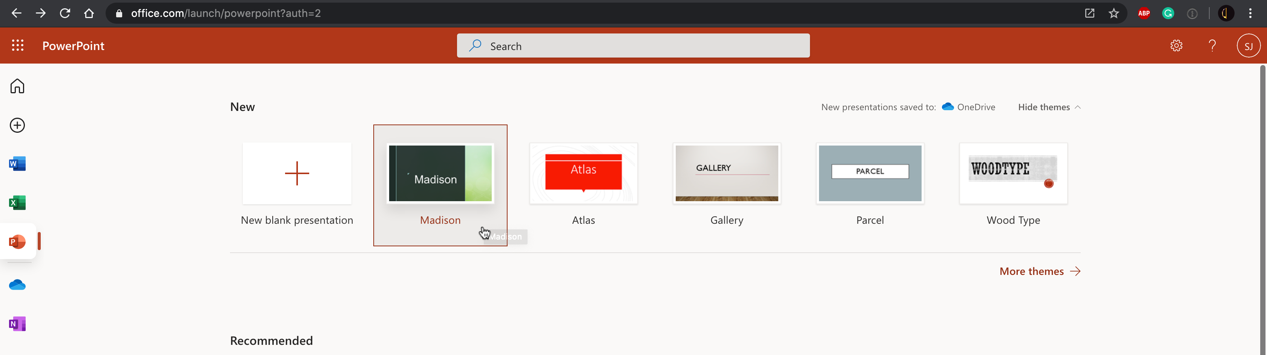

# Exercise 2: Add new slide and change slide layout and design

1. Click **New Slide**
2. 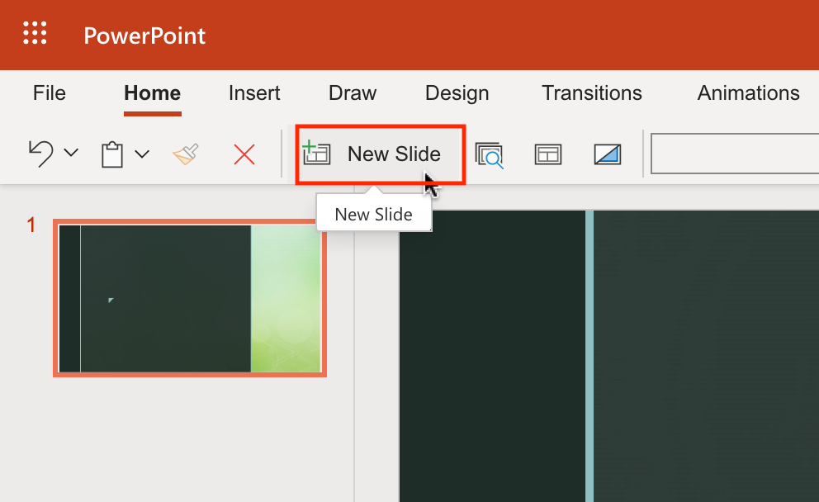
3. Select **Picture with Caption** type slide and click **Add Slide**.
4. 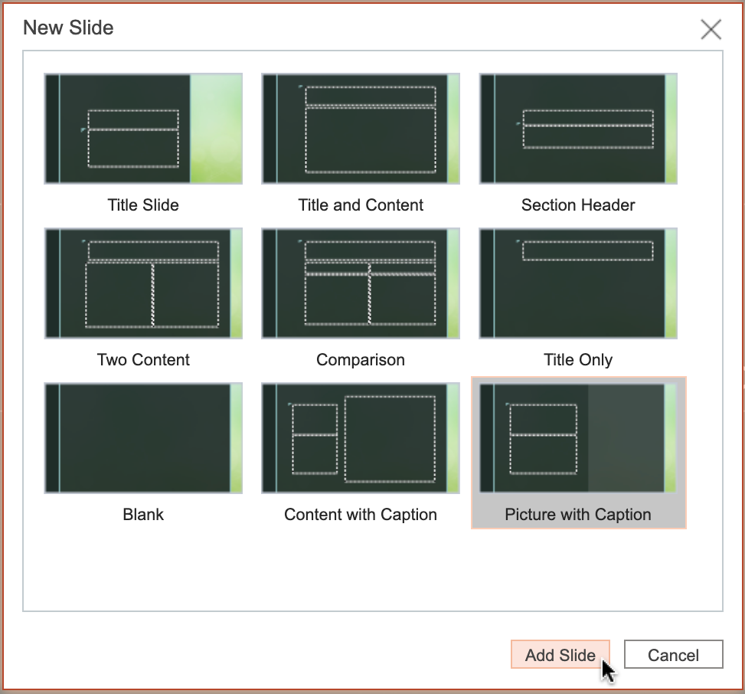
5. Go back to slide 1 and click **Layout** icon.
6. 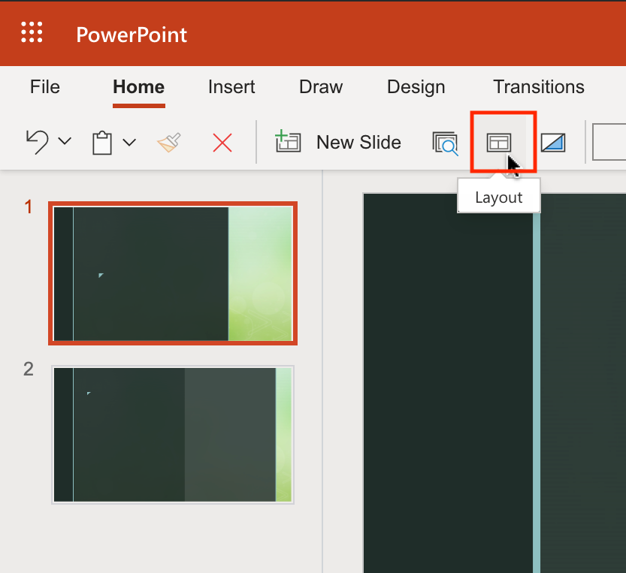
7. Select **Title Only** layout and click **Change Layout**.
8. 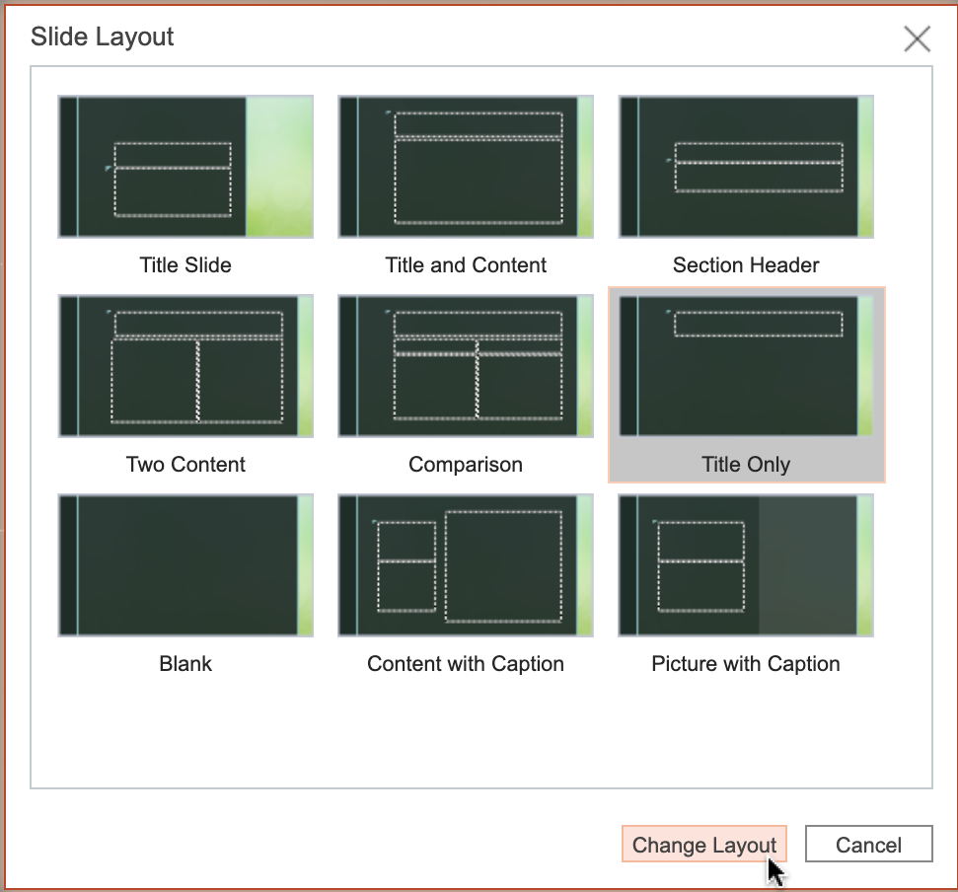
9. Select **Designer**. Select any design from the right **Designer** pane to change the design of slide 1.
10. 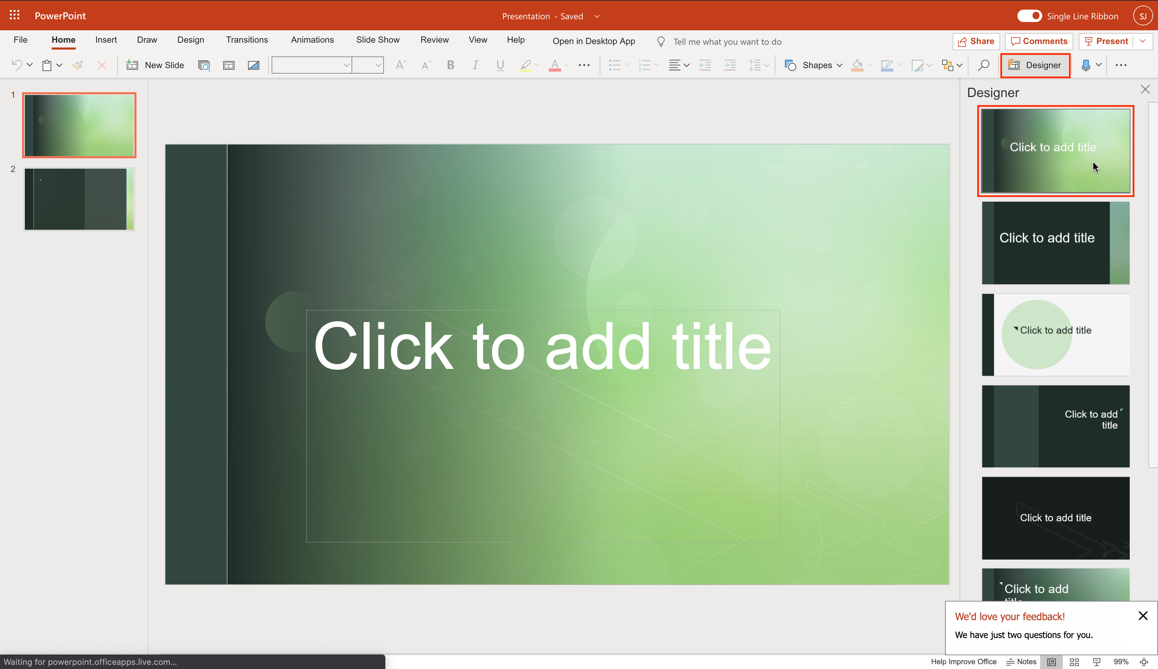

# Exercise 3: Add text, images, art, and videos

1. Switch to slide 1 if needed. Click on the textbox **Click to add title** and type "Basics of PowerPoint" as title.
2. 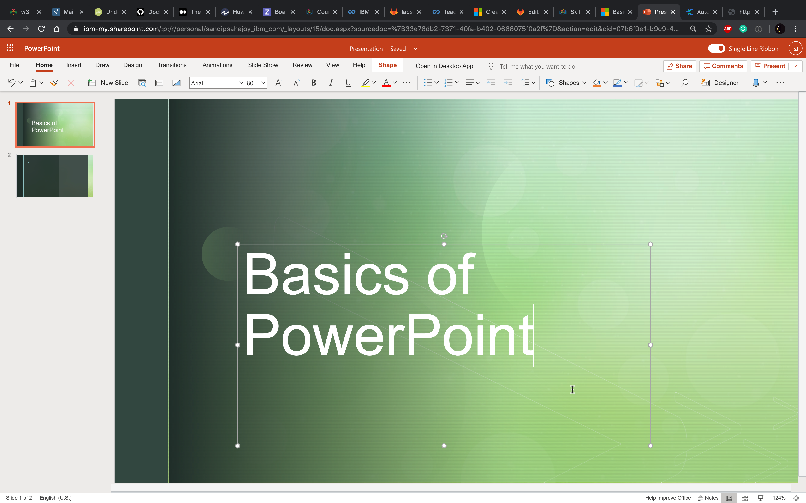
3. Switch to slide 2. Click on the textbox **Click to add title** and type "Objectives" as title.
4. Click on the textbox **Click to add text** and type:
   * Create presentations from scratch/ template
   * Add new slide and change slide layout and design
   * Add text, images, art, and videos
5. Select all text from second textbox and click **Bulleted Library** to select a bullet option.
6. 
7. Now click the web search option like below from the right-hand section of the slide.
8. 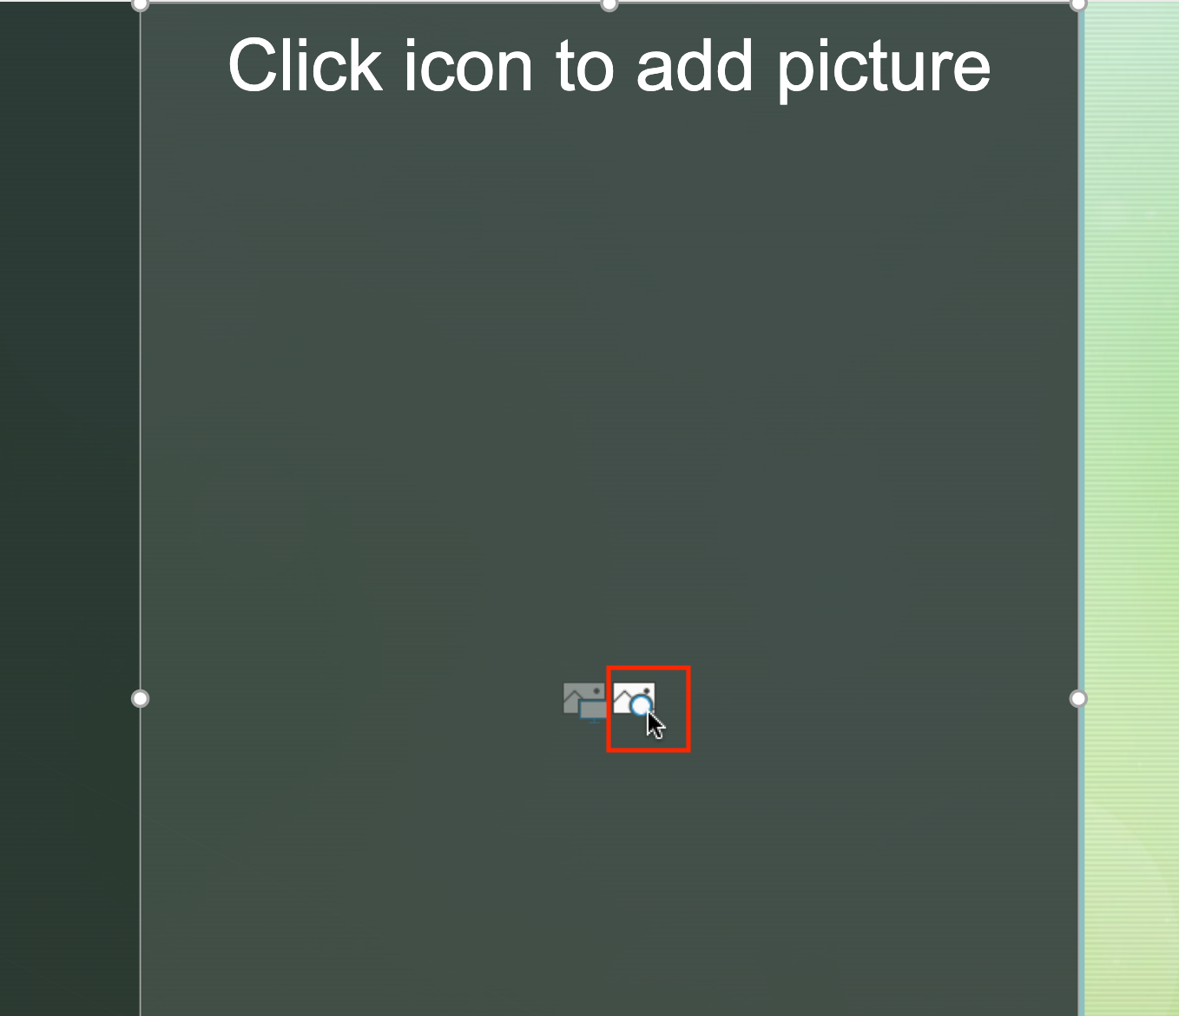
9. Type "presentation" and select an appropriate picture you like to add to your slide. Then click **Insert**.
10. 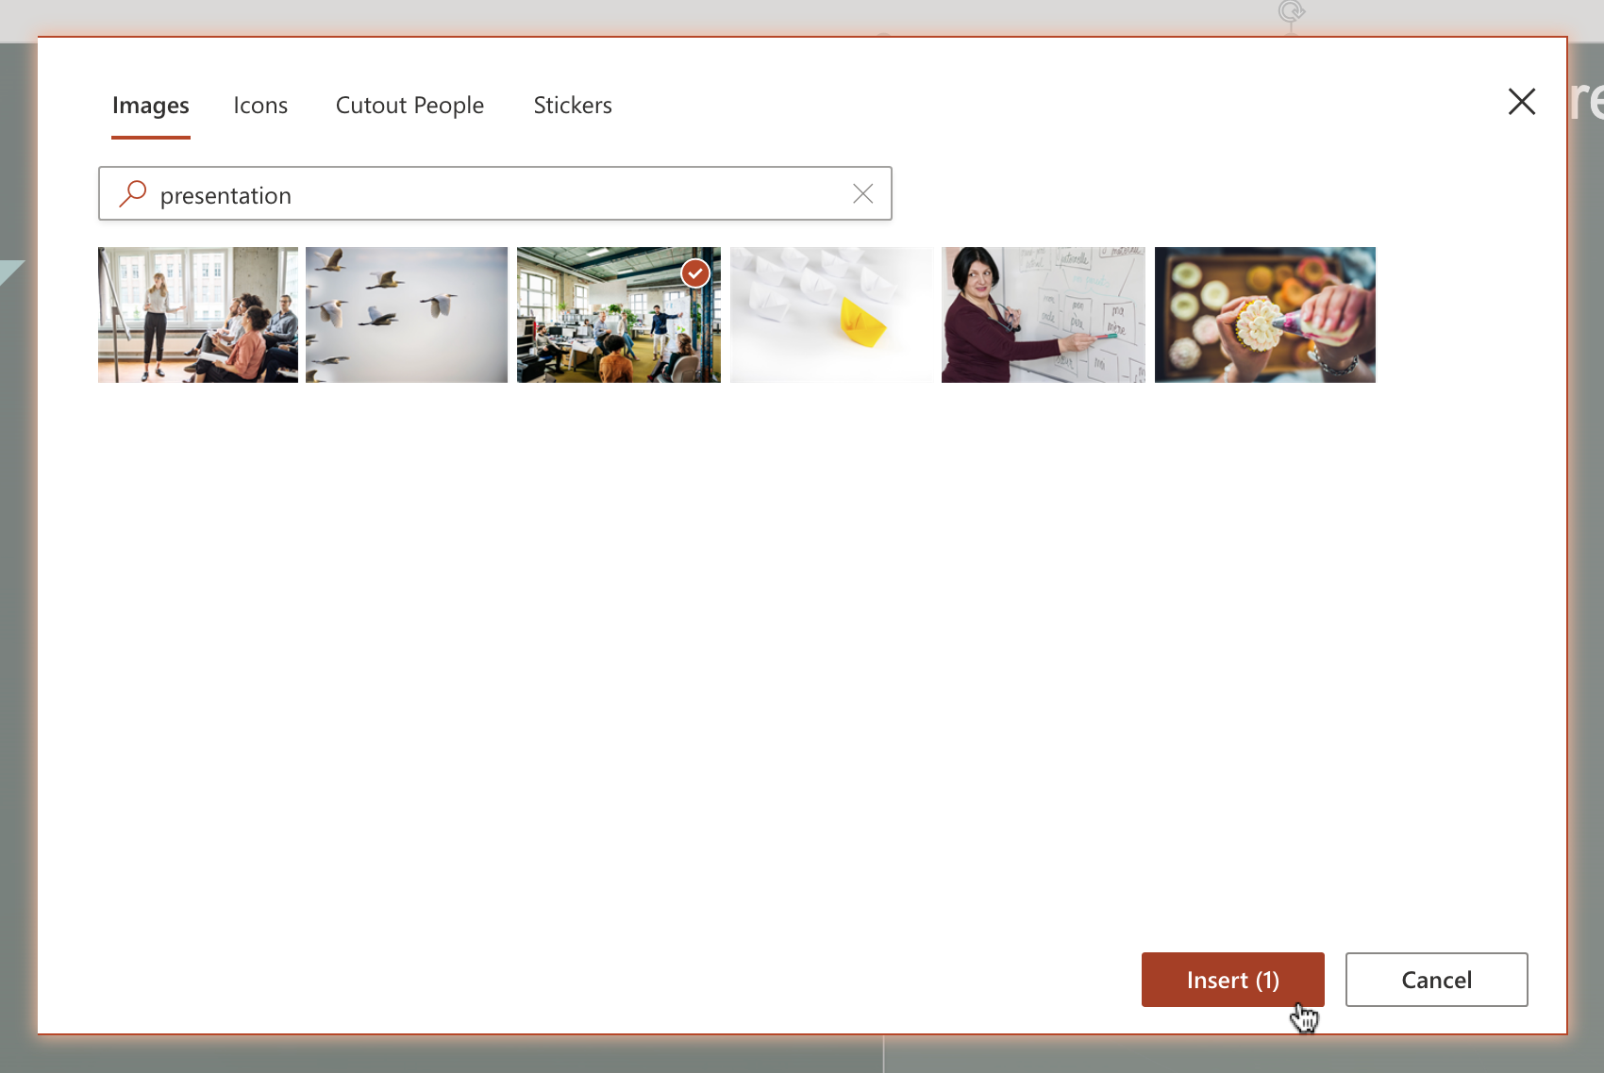
11. From the right **Designer** pane , select a design you like to visualize the inserted picture on the slide.
12. 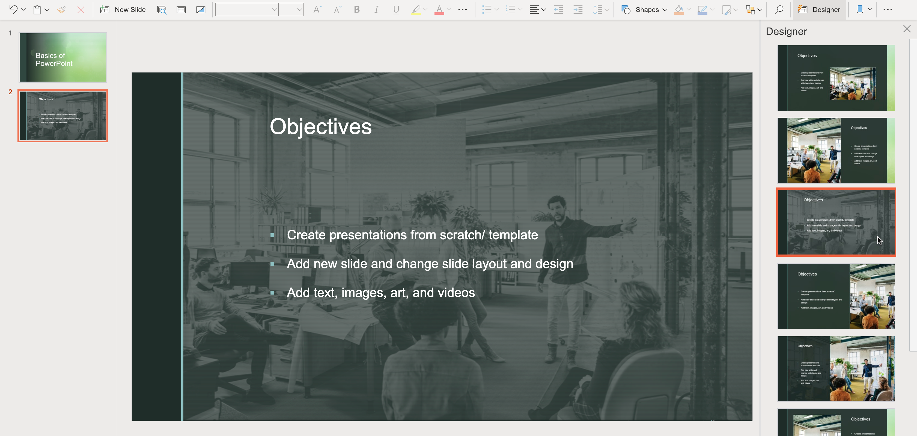

### Congratulations! You have completed this Lab.

# Hands-on Lab : Save your PowerPoint Presentation as PDF

**Estimated time needed:** 5 minutes

Microsoft PowerPoint is the most widely used presentation software even three decades after its initial release. For all these years it has been available as a standard application that needed to be installed on your desktop; but it is not just a desktop app anymore. Now, you can even use PowerPoint when you're online by using 'PowerPoint for the web' - and run it right in your web browser without installing anything on your desktop!

'PowerPoint for the Web' (sometimes referred to as PowerPoint Online) can be used at no charge as part of a free Microsoft account. Although it does not have all of the capabilities of the desktop and paid online versions, the free web version provides many of the key features.

# Software Used in this Lab

For the story telling/project report of this module, you will be using the free 'PowerPoint for the web' version as this is available to everyone.

Although you can use the PowerPoint Desktop software if you have access to this version, it is recommended that you use PowerPoint for the web for your project report as it is available for free, and there are some small differences in the interface and available features. If you do not yet have access to PowerPoint for the Web, you can follow the instructions in the following lab to get started with it: [Hands-on Lab - Getting Started with PowerPoint for the Web](https://cocl.us/DA0321EN-Lab-Getting_Started_with_PowerPoint_for_the_Web)

# Objectives

After completing this lab, you will be able to:

* Save your PowerPoint Presentation as PDF in PowerPoint for the Web
* Save your PowerPoint Presentation as PDF in PowerPoint Desktop for Windows/macOS

# Exercise 1: Save your PowerPoint Presentation as PDF in PowerPoint for the Web

In this exercise, you will save your PowerPoint presentation as PDF in PowerPoint for the web.

1. Open your presentation file with PowerPoint for the web.
2. 
3. Click **File**.
4. 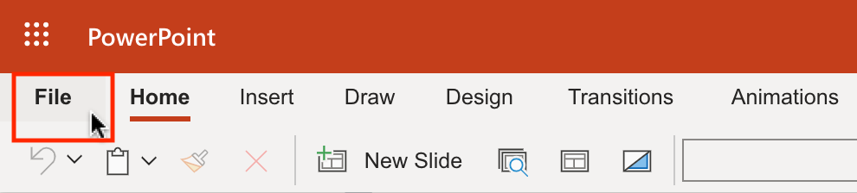
5. Select **Download As**. Then select **Download as PDF**.
6. 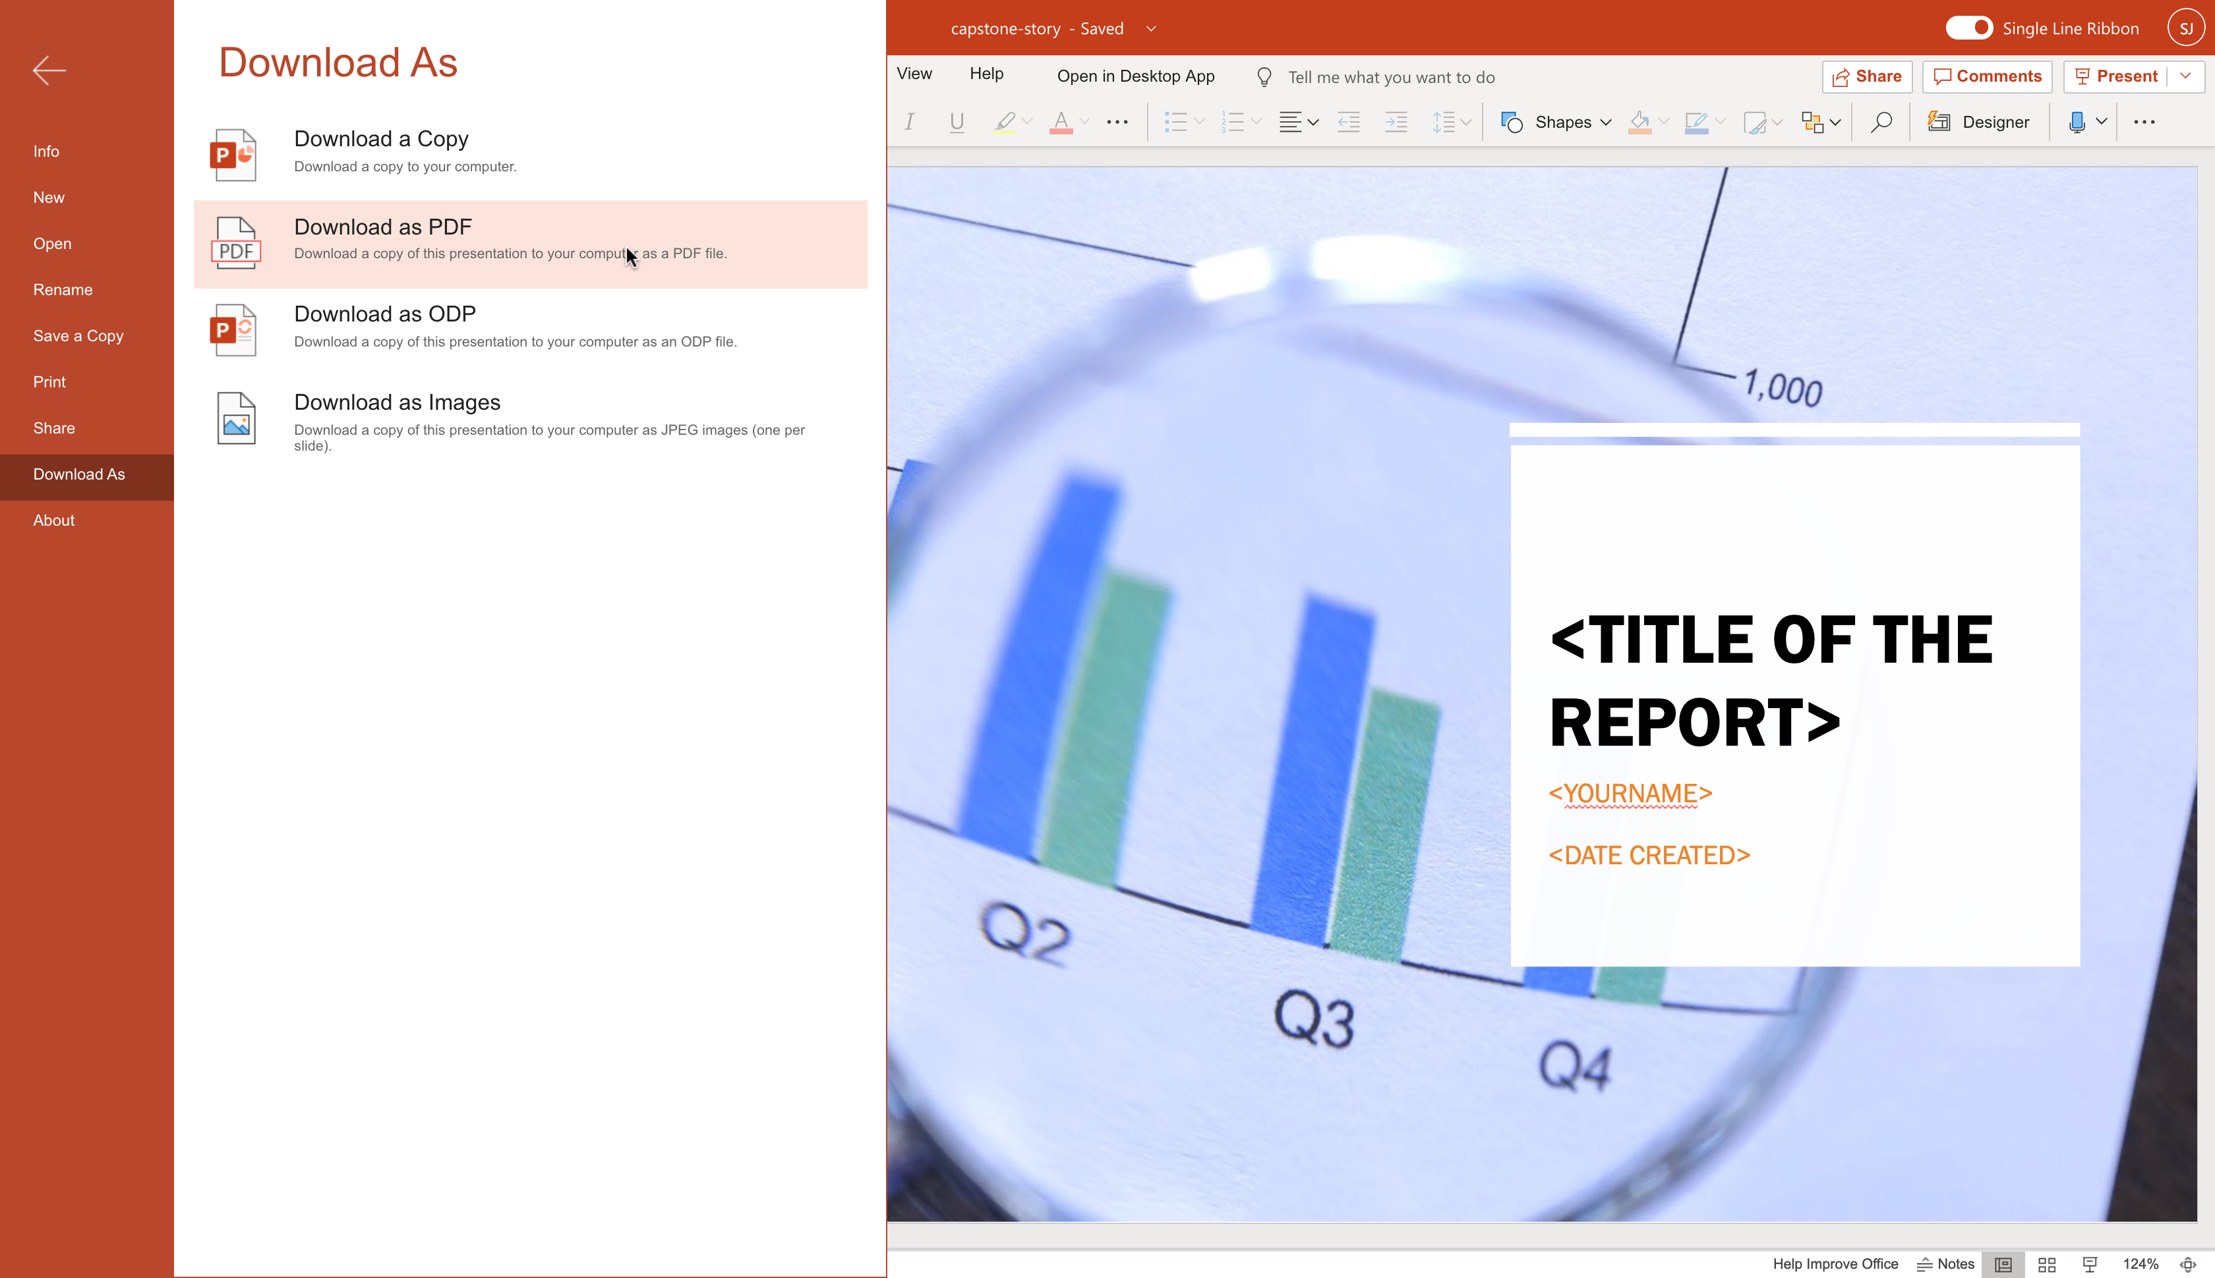
7. Click **Download**.
8. 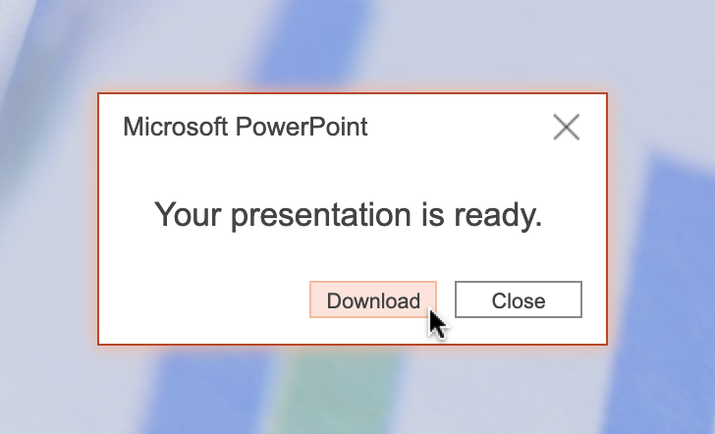
9. Save to your local storage.

# Exercise 2: Save your PowerPoint Presentation as PDF in PowerPoint Desktop for Windows/macOS

In this exercise, you will save your PowerPoint presentation as PDF in PowerPoint Desktop for Windows/macOS.

1. Open your presentation file with PowerPoint Desktop for Windows/macOS.
2. 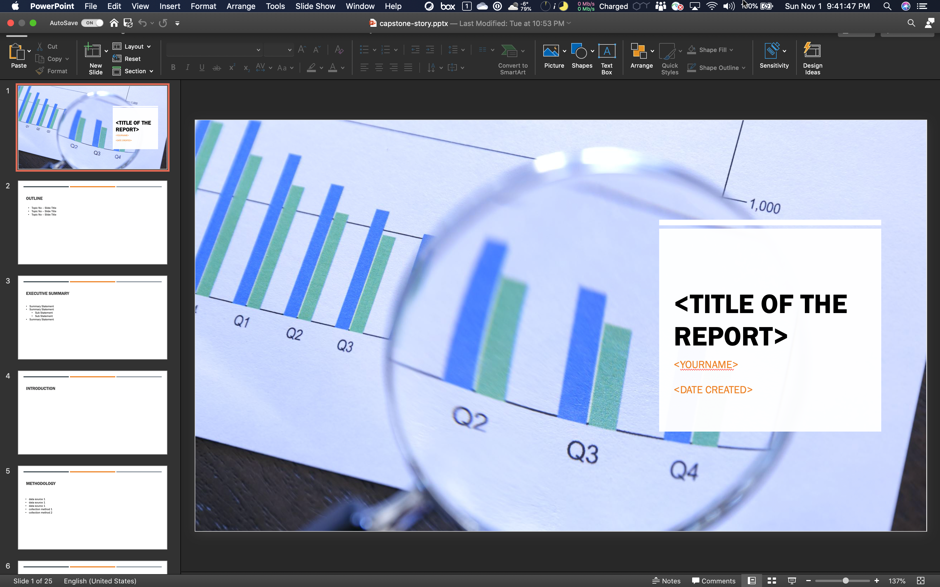
3. Click **File**. Then select **Export...**.
4. 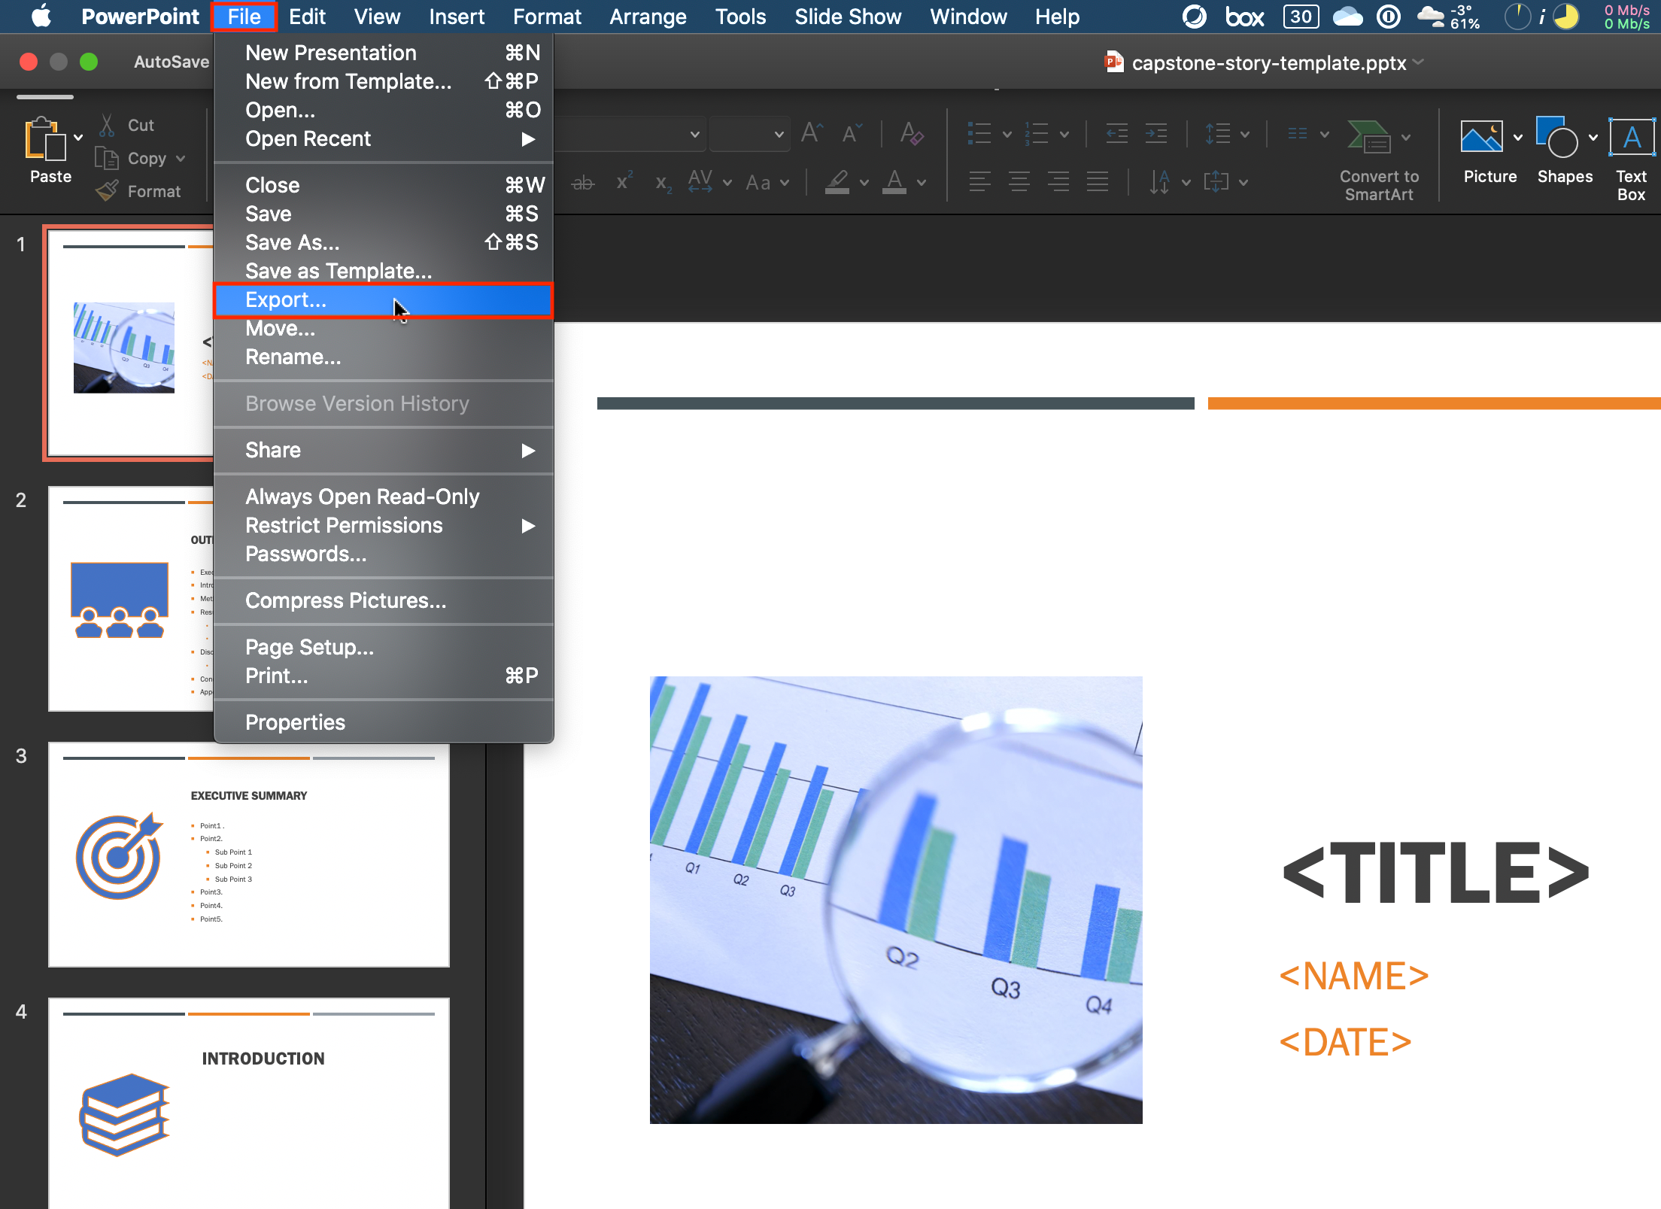
5. To save the file as PDF to your local storage, click **Export** making sure the File Format specifies PDF.
6. 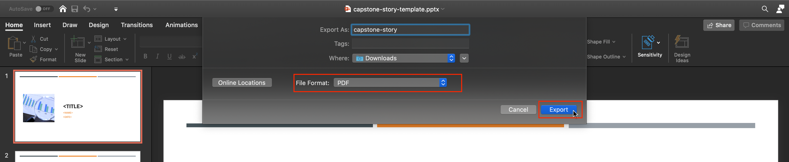

### Congratulations! You have completed this Lab.